Nama : Hafidh Iman Nofandi

Kelas : TI2E

NIM : 1541183001

**TUGAS 3 GUI**

**1. Visual Basic form parent**

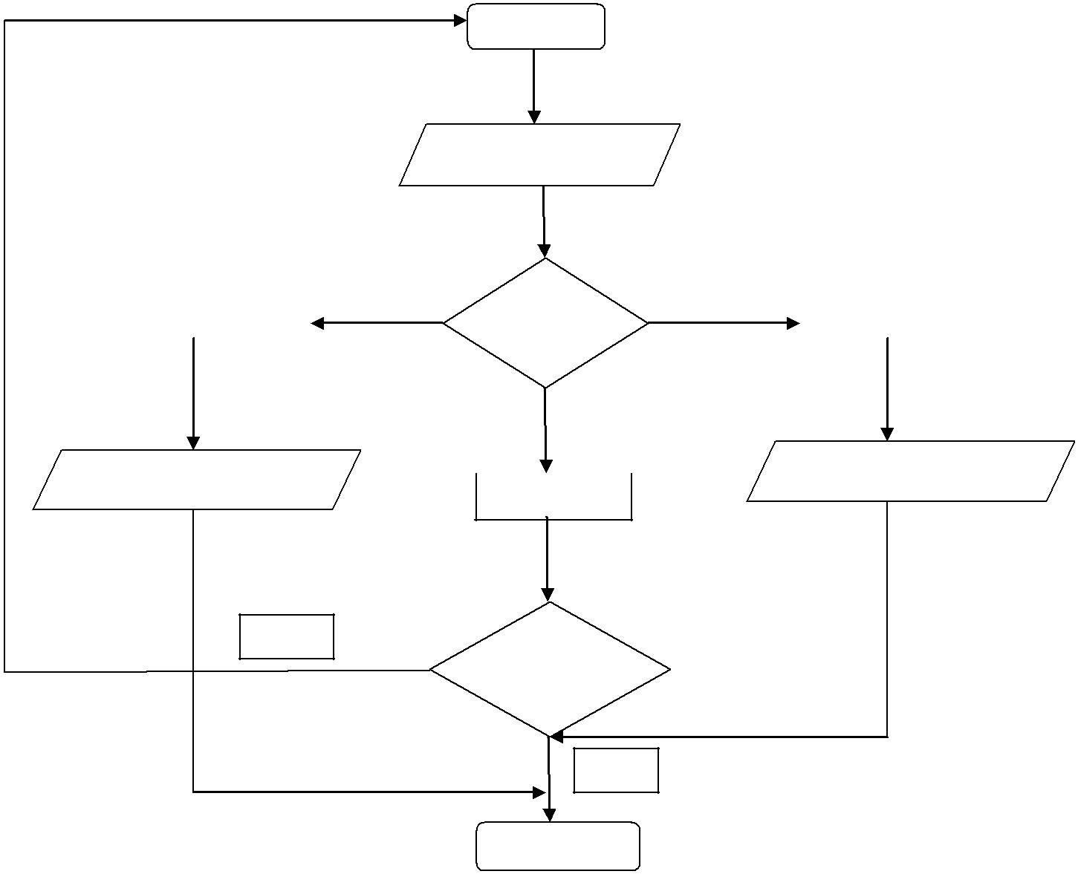

Mulai

Masukkan pilihan

|  |  |  |  |
| --- | --- | --- | --- |
| Program bintang | Memilih | Matriks kalkulator |  |
| Kondisi |  |
|  |  |  |
|  |  |  |

|  |  |  |  |
| --- | --- | --- | --- |
| Hasil proses program |  | Hasil proses program |  |
|  |  |
|  |  |  |

Tidak

Keluar

Ya / Tidak

YA

Selesai

**2. Program Bintang pyramid**

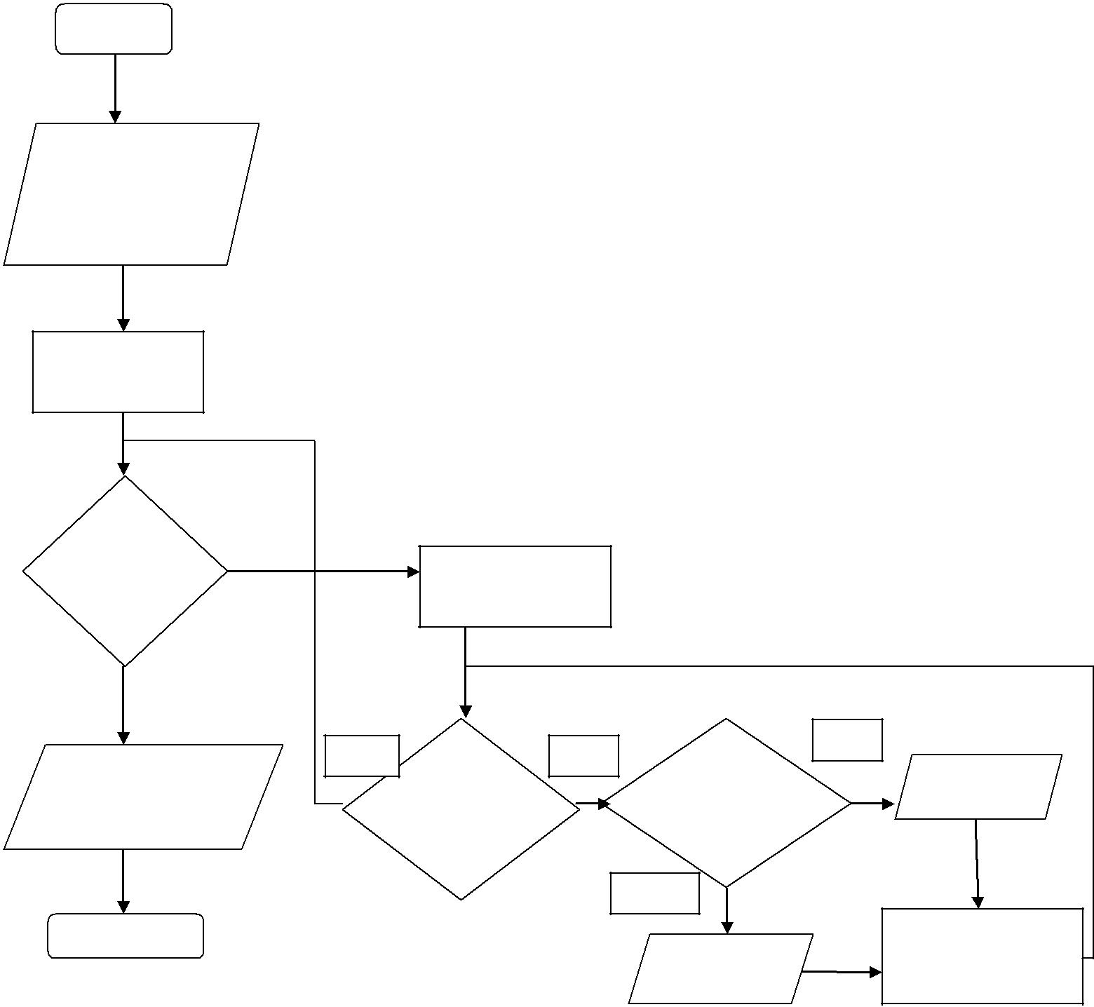

Mulai

Inputan batasKolom1 batasKolom2

Untuk baris=1

Sampai batas

|  |  |  |  |  |
| --- | --- | --- | --- | --- |
| Apakah |  |  |  |  |
| Batas=1/ | Untuk kolom=1 |  |  |  |
| <=batas | <=batas*2-1 |  |  |  |
| Tidak | Ya |  | Ya |  |
| Jika kolom < |  |  |
| Textbox2.text | Apakah | Cetak=” “ |  |
| Bataskolom1/ |  |
| =hasil | kolom=1/ |  |  |
| <=batas*2-1 | Bataskolom2 |  |  |
|  |  |  |
|  |  | Tidak |  |  |
| Selesai |  |  | Bataskolom1 -=1 |  |
|  |  | Bataskolom2 +=1 |  |
|  |  | Cetak=” “ |  |
|  |  | Hasil &= vbclrf |  |
|  |  |  |  |

3. **Program Holow pyramid**

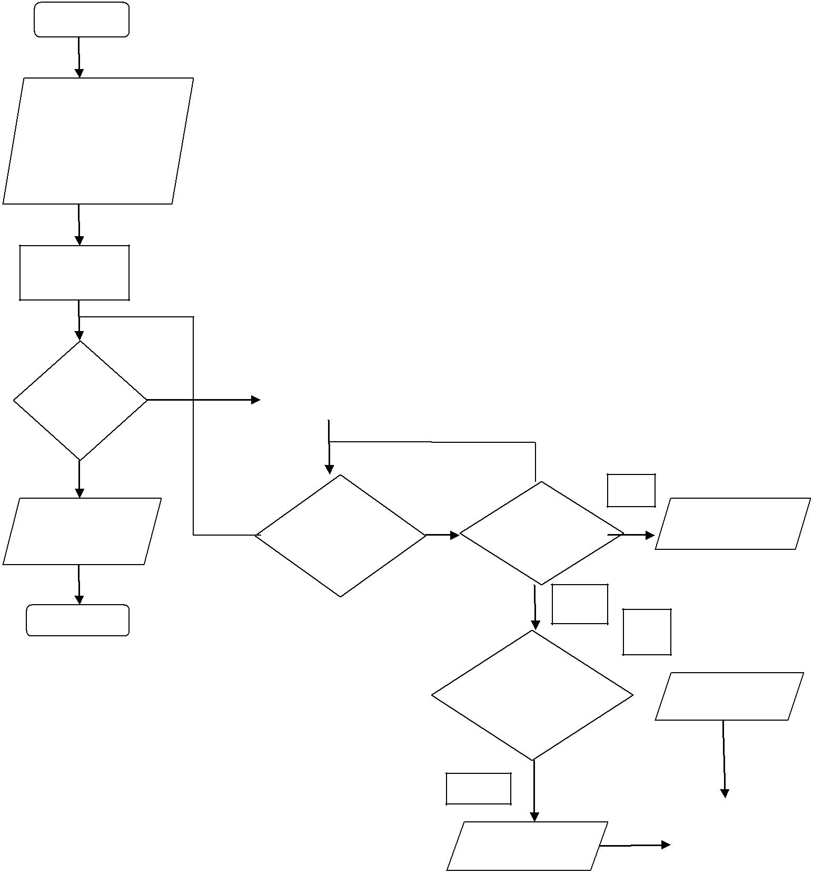

Mulai

Inputan

Bataskolom1=batas

Bataskolom2=batas

Cetak hasil=” “

Untukbaris=1

Sampai batas

|  |  |  |
| --- | --- | --- |
| Apakah | Untuk kolom=1 |  |
| Batas=1/ | <=batas*2-1 |  |
| <=batas |  |  |
|  |  |

|  |  |  |
| --- | --- | --- |
| Textbox2.text | Apakah |  |
|  |  |
| =hasil | kolom=1/ |  |
|  |  |
|  | <=batas*2-1 |  |

Selesai

ya

Apakah Cetak &= “*”

Baris<batas

Tidak

ya

Jikakolom=

Bataskolom1/=  Cetak &= “*”

Bataskolom2

Tidak

|  |  |  |
| --- | --- | --- |
|  | Bataskolom1 -=1 |  |
| Cetak &= “*” | Bataskolom2 +=1 |  |
| Hasil &= vbclrf |  |
|  |  |
|  |  |  |

4. **Program Inverted pyramid**

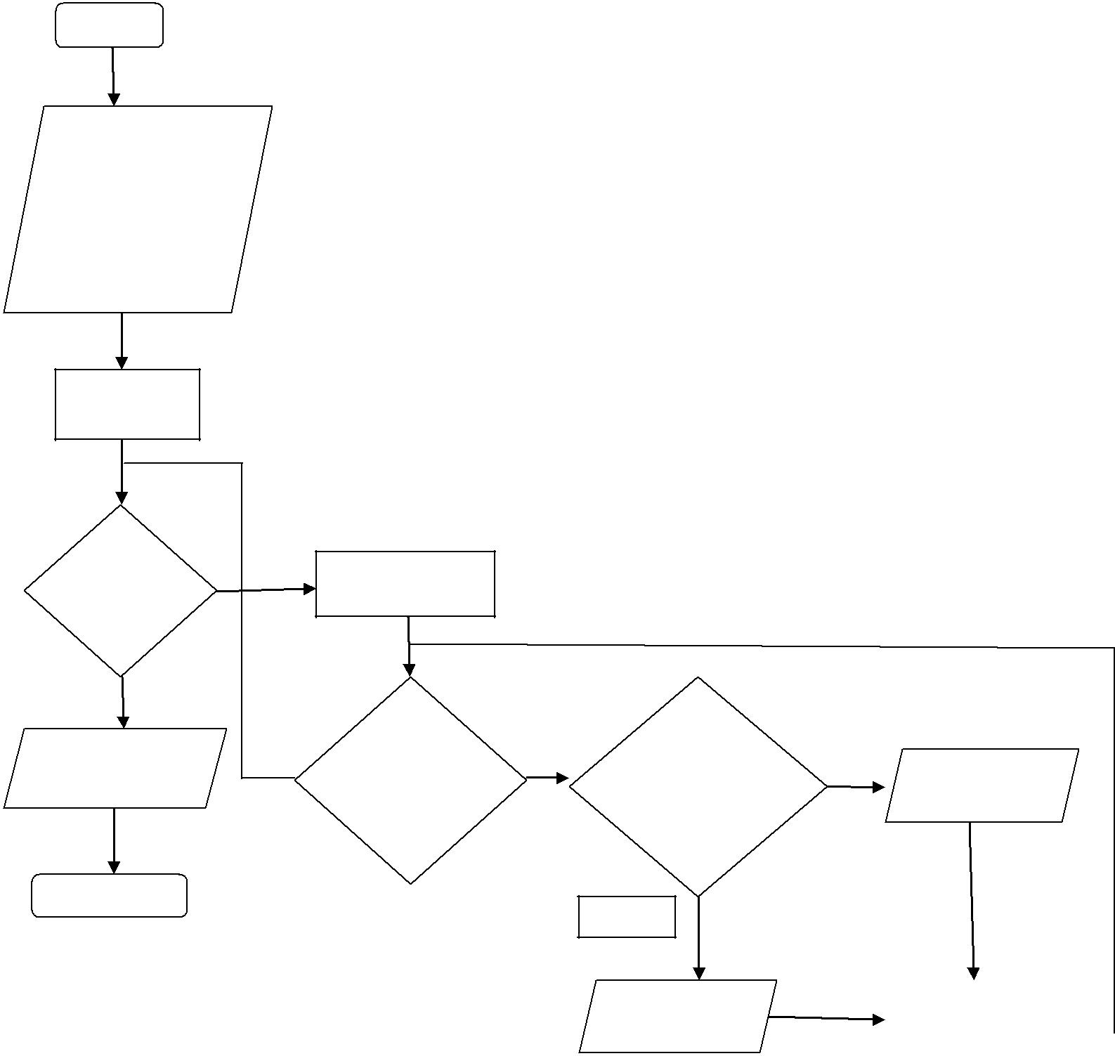

Mulai

Inputan Bataskolom1 =0 Bataskolom2= batas*2-1 cetak = “ “

For baris = 1

Sampai batas

Apakah

Batas=1/

<=batas

Textbox2.text

=hasil

Selesai

Untuk kolom=1 <=batas*2-1

|  |  |  |  |  |  |
| --- | --- | --- | --- | --- | --- |
|  | Ya |  |  |  |  |
| Apakah | Jikakolom> | Ya |  |  |
|  |  |  |
|  |  |  |  |
|  |  |  |  |
| kolom=1/ |  | Bataskolom1/ |  | Hasil = “ “ |  |
| <=batas*2-1 |  |  |  |
|  | <Bataskolom2 |  |  |  |

Tidak

|  |  |  |  |
| --- | --- | --- | --- |
| Hasil = “ “ | Bataskolom1 +=1 |  |  |
| Bataskolom2 -=1 |  |  |
|  |  |  |
|  |  |  |
|  | Hasil &= vbclrf |  |  |
|  |  |  |  |

**5. Program Hollow Inverted pyramid**

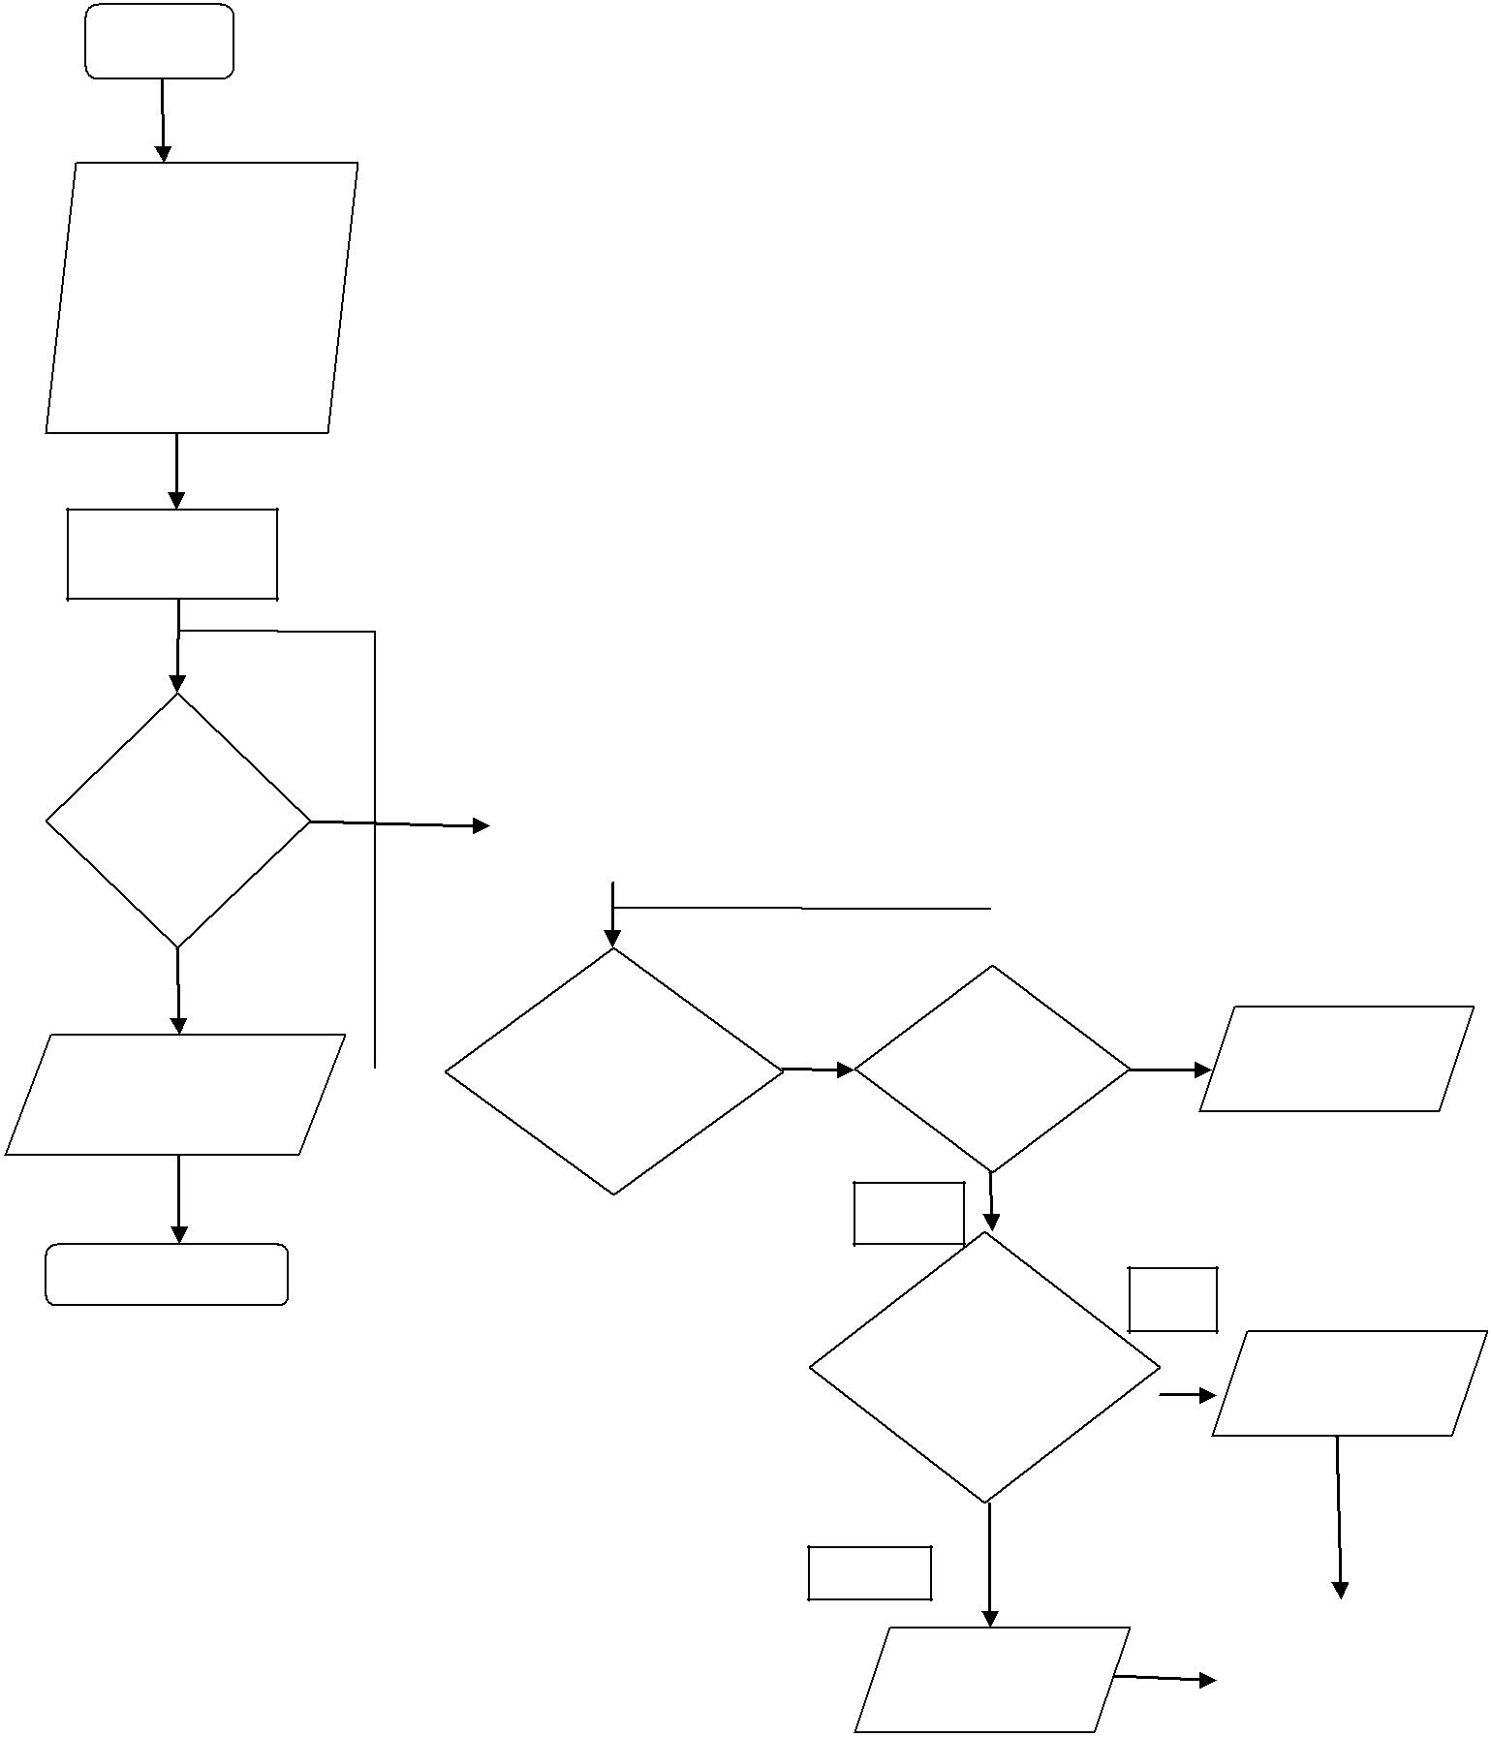

Mulai

Inputan Bataskolom1 =1 Bataskolom2= batas*2-1 cetak = “ “

For baris = 1

Sampai batas

|  |  |  |
| --- | --- | --- |
| Apakah |  |  |
| Batas=1/ | Untuk kolom=1 |  |
|  |  |
| <=batas | <=batas*2-1 |  |
|  |  |
|  |  |  |

|  |  |  |  |
| --- | --- | --- | --- |
|  |  | Apakah |  |
| Textbox2.text |  | kolom=1/ |  |
|  |  |
|  |  |  |
| =hasil |  | <=batas*2-1 |  |
|  |  |  |

Selesai

|  |  |  |  |  |
| --- | --- | --- | --- | --- |
|  |  |  |  |  |
|  |  | Ya |  |  |
| Apakah | |  | Hasil = “ *“ |  |
|  |  |  |  |
| Baris = 1 | |  |  |  |

Tidak

Ya

Jikakolom=

Bataskolom1/

Hasil = “ *“

=Bataskolom2

Tidak

|  |  |
| --- | --- |
|  | Bataskolom1 +=1 |
| Hasil = “ “ | Bataskolom2 -=1 |
|  | Hasil &= vbclrf |
|  |  |

**6. Form 3**

**Matrix Kalkulator**

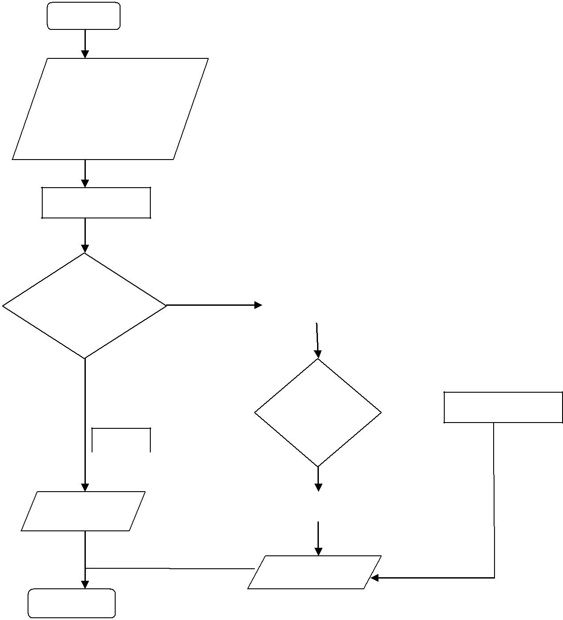

Mulai

Input matriks baris 1

Input matriks kolom 1

Input matriks baris 2

Input matriks kolom 2

Fungsi Cek

|  |  |  |  |  |
| --- | --- | --- | --- | --- |
| Apakah | Ya |  | Fungsi |  |
| Matriks sudah |  |  | Copy to array |  |
| Benar ? |  |  |  |  |
|  |  |  |  |

Operasi

Tambah/  Proses tambah

Kurang

|  |  |  |  |  |
| --- | --- | --- | --- | --- |
|  | Tidak | |  |  |
|  |  |  |  |  |
| Pesan error | | | Proses kurang |  |
|  |  |
|  |  |  |  |  |

Ceteak hasil

Selesai